温州大学计算机与人工智能学院
操作系统 实验报告
实验名称： | 银行家算法
班 级： | 24网工 | 姓 名： | 韩贤煜 | 学号： | 24211835201
实验地点： | 5B202 | 日 期： | 2026/05/29

一、实验目的：
理解银行家算法避免死锁的工作原理
掌握银行家算法避免死锁的工作过程
掌握系统安全性检测算法
二、实验内容和要求：
使用C语言设计并实现银行家算法模拟程序
三、实验结果
源代码:
#define MAX_P 100
#define MAX_R 100

#include <iostream>
using namespace std;

int n, m;

int Max[MAX_P][MAX_R];
int Allocation[MAX_P][MAX_R];
int Need[MAX_P][MAX_R];

int Request[MAX_R];
int Available[MAX_R];

int Work[MAX_R];
bool Finish[MAX_P];
int Seq[MAX_P];

bool checkSafe();
void requestLoop();
void releaseProcess(int p_num);

void calcNeed()
{
int i, j;

for (i = 0; i < n; i++)
{
for (j = 0; j < m; j++)
{
Need[i][j] = Max[i][j] - Allocation[i][j];
}
}
}

bool checkProcess(int p_num)
{
if (p_num < 0 || p_num >= n)
{
cout << "进程" << p_num << "不存在!" << endl;
return false;
}

return true;
}

void banker(int p_num)
{
int i, j;

for (i = 0; i < m; i++)
{
if (Request[i] > Need[p_num][i])
{
cout << "进程" << p_num << "的请求超过了它的最大需求!" << endl;
return;
}
}

for (i = 0; i < m; i++)
{
if (Request[i] > Available[i])
{
cout << "进程" << p_num << "的请求无法满足!" << endl;
return;
}
}

// 尝试分配
for (i = 0; i < m; i++)
{
Available[i] -= Request[i];
Allocation[p_num][i] += Request[i];
Need[p_num][i] -= Request[i];
}

if (checkSafe())
{
cout << "进程" << p_num << "资源分配成功" << endl;

bool isAllZero = true;

for (i = 0; i < m; i++)
{
if (Need[p_num][i])
{
isAllZero = false;
break;
}
}

if (isAllZero)
releaseProcess(p_num);
}
else
{
cout << "进程" << p_num << "资源分配失败" << endl;

for (i = 0; i < m; i++)
{
Available[i] += Request[i];
Allocation[p_num][i] -= Request[i];
Need[p_num][i] += Request[i];
}
}
}

bool checkSafe()
{
int i, j;

for (i = 0; i < m; i++)
Work[i] = Available[i];

for (i = 0; i < n; i++)
Finish[i] = false;

int cnt = 0;
bool isChanged = true;

while (isChanged)
{
isChanged = false;

for (i = 0; i < n; i++)
{
if (!Finish[i])
{
bool flag = true;

for (j = 0; j < m; j++)
{
if (Need[i][j] > Work[j])
{
flag = false;
break;
}
}

if (flag)
{
Finish[i] = true;
isChanged = true;
Seq[cnt] = i;
cnt++;

for (j = 0; j < m; j++)
{
Work[j] += Allocation[i][j];
}
}
}
}
}

for (i = 0; i < n; i++)
{
if (!Finish[i])
{
cout << "无法找到安全序列" << endl;
return false;
}
}

cout << "安全序列: ";

for (i = 0; i < n; i++)
{
if (i != 0)
cout << "->";

cout << Seq[i];
}

cout << endl;

return true;
}

void releaseProcess(int p_num)
{
int i, j;

bool hasR = false;

for (i = 0; i < m; i++)
{
if (Allocation[p_num][i] > 0)
{
hasR = true;
break;
}
}

if (!hasR)
{
return;
}

for (int j = 0; j < m; j++)
{
Available[j] += Allocation[p_num][j];
Max[p_num][j] = 0;
Allocation[p_num][j] = 0;
Need[p_num][j] = 0;
}

cout << "进程P" << p_num << "运行结束，系统已成功回收其占有的全部资源！" << endl;
}

void print()
{
int i, j;

printf("----------------------- 当前系统资源状态 -----------------------\n");
printf("进程\tMax\tAllocation\tNeed\tAvailable\n");

for (i = 0; i < n; i++)
{
printf("P%d\t", i);
for (j = 0; j < m; j++)
printf("%d ", Max[i][j]);
printf("\t");
for (j = 0; j < m; j++)
printf("%d ", Allocation[i][j]);
printf("\t\t");
for (j = 0; j < m; j++)
printf("%d ", Need[i][j]);
printf("\t");
if (i == 0)
{
for (j = 0; j < m; j++)
printf("%d ", Available[j]);
}
printf("\n");
}
printf("----------------------------------------------------------------\n");
}

void input1()
{
int i, j;
cout << "--- 进入手动输入模式 ---" << endl;
cout << "请输入进程数量n: ";
cin >> n;
cout << "请输入资源类数量m: ";
cin >> m;

cout << "请输入可用资源向量Available(" << m << "个数值): ";
for (j = 0; j < m; j++)
{
cin >> Available[j];
}

cout << "请输入最大需求矩阵Max(" << n << "x" << m << "):\n";
for (i = 0; i < n; i++)
{
cout << "P" << i << "的最大需求: ";
for (j = 0; j < m; j++)
{
cin >> Max[i][j];
}
}

cout << "请输入分配矩阵Allocation(" << n << "x" << m << "):\n";
for (i = 0; i < n; i++)
{
cout << "P" << i << "的已分配量: ";
for (j = 0; j < m; j++)
{
cin >> Allocation[i][j];
}
}

calcNeed();
print();

cout << "执行初始状态安全性检查..." << endl;
checkSafe();

requestLoop();
}

void test1()
{
cout << "--- 进入内置测试样例模式 ---" << endl;

n = 5;
m = 3;

Available[0] = 3;
Available[1] = 3;
Available[2] = 2;

int sampleMax[5][3] = {
{7, 5, 3},
{3, 2, 2},
{9, 0, 2},
{2, 2, 2},
{4, 3, 3}};

int sampleAlloc[5][3] = {
{0, 1, 0},
{2, 0, 0},
{3, 0, 2},
{2, 1, 1},
{0, 0, 2}};

for (int i = 0; i < n; i++)
{
for (int j = 0; j < m; j++)
{
Max[i][j] = sampleMax[i][j];
Allocation[i][j] = sampleAlloc[i][j];
}
}

calcNeed();
print();

cout << "\n执行初始状态安全性检查..." << endl;
checkSafe();

requestLoop();
}

void requestLoop()
{
char choice;
do
{
int p_num;
cout << "\n请输入请求资源的进程编号(0 ~ " << n - 1 << "): ";
cin >> p_num;

if (checkProcess(p_num))
{
cout << "请输入进程P" << p_num << " 的资源请求向量Request(" << m << "个数值): ";
for (int i = 0; i < m; i++)
{
cin >> Request[i];
}
banker(p_num);
}

print();

cout << "\n是否继续输入新的资源请求?(y/n): ";
cin >> choice;
} while (choice == 'y' || choice == 'Y');
}

int main()
{
cout << "选择一种运行模式" << endl;
cout << "1: 内置测试样例运行" << endl;
cout << "2: 手动输入运行" << endl;
cout << "3: 退出" << endl;

int choice;

while (true)
{
cin >> choice;

if (choice == 1)
{
test1();
break;
}
else if (choice == 2)
{
input1();
break;
}
else if (choice == 3)
{
break;
}
else
{
cout << "非法输入" << endl;
cout << "选择一种运行模式" << endl;
cout << "1: 内置测试样例运行" << endl;
cout << "2: 手动输入运行" << endl;
cout << "3: 退出" << endl;
cout << "请重新输入" << endl;
}
}

return 0;
}
运行效果:
(1)能成功分配资源
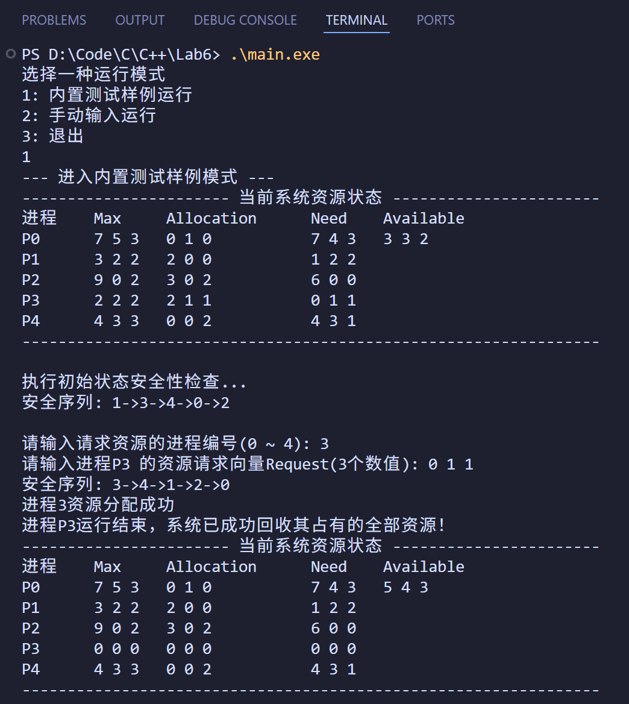
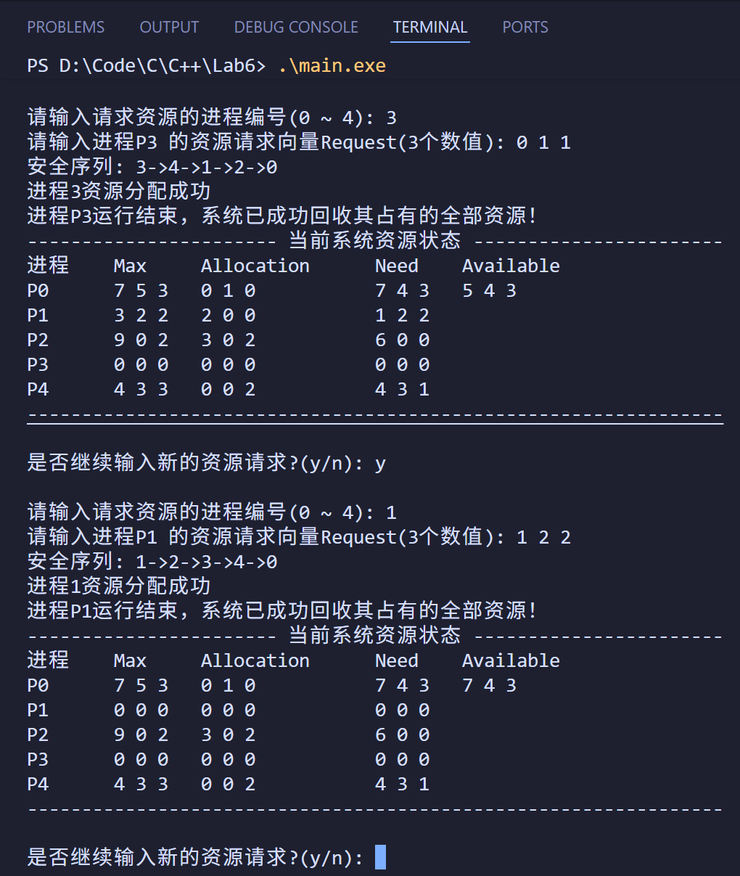
(2)不能成功分配资源
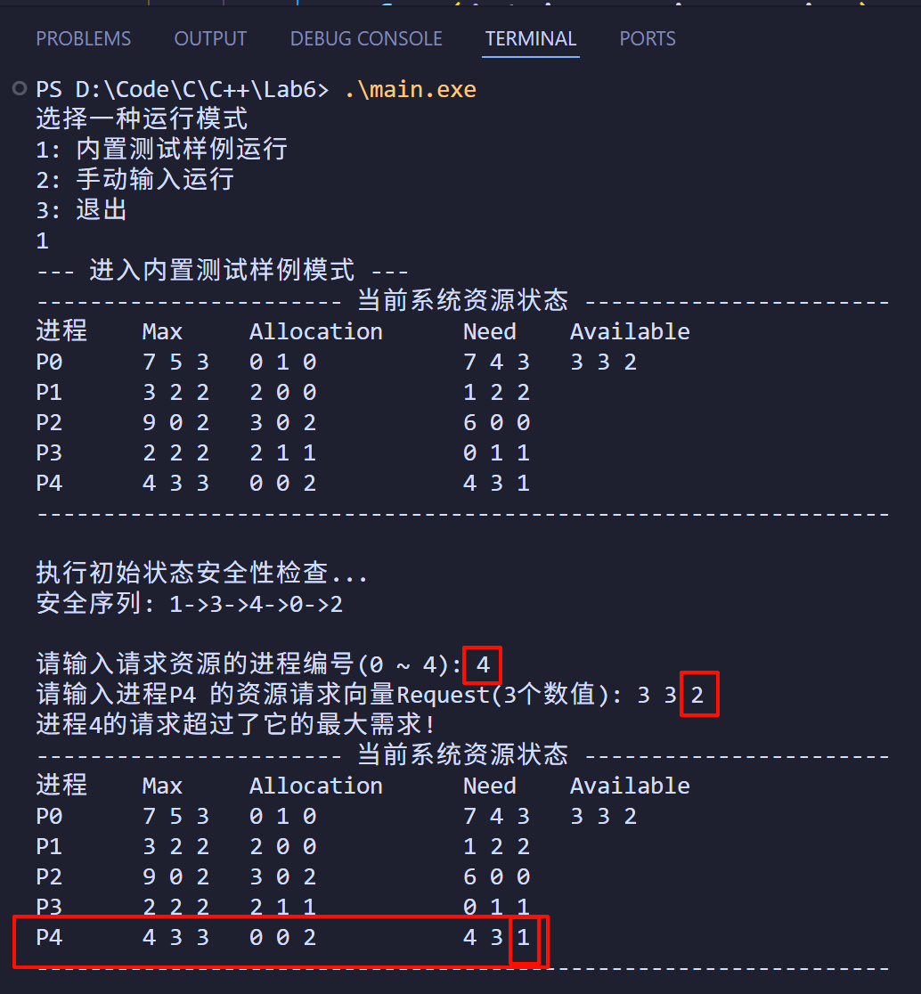
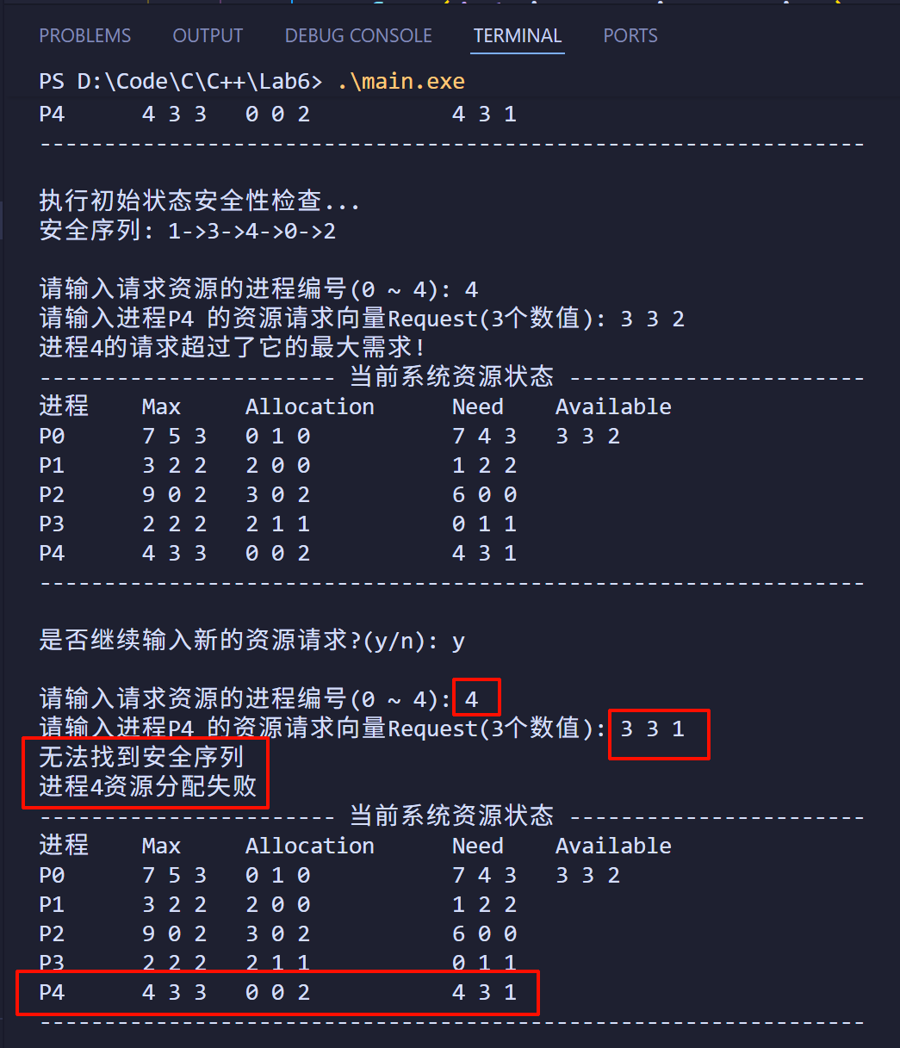

评价依据与标准 | 赋分区间 | 实验评分
能够使用命令操作、接口调用、代码编写等方式实现实验要求中给出的所有任务目标，运行结果正确。 | [90-100]
能够使用命令操作、接口调用、代码编写等方式实现实验要求中给出的大部分任务目标，主要结果运行正确。 | [80-90）
能够使用命令操作、接口调用、代码编写等方式实现实验要求中给出的部分任务目标，部分结果运行正确。 | [60-80）
只能使用命令操作、接口调用、代码编写等方式实现实验要求中给出的少部分任务目标或无法实现任务目标，多数或所有结果运行不正确。 | [0-60）

